**Dry Rubbed Roast Turkey**

Serves 6 with leftovers   
  
INGREDIENTS   
1 whole organic turkey (10 to 12 pounds) or just turkey breast, if only white meat is desired and you have less time to prepare.   
1-2 cups water for the pan to add moisture to meat   
  
Turkey Rub Ingredients   
Rub turkey all over with this recipe:   
  
1/4-cup fresh chopped sage   
1/4-cup fresh chopped thyme   
2 tablespoons grated orange zest   
2 tablespoons kosher salt   
  
PREPARATION   
1. Put turkey in pan large and place in refrigerator overnight.   
2. Bring turkey out 1 hour before putting it in an oven heated to 400 degrees.   
3. Place turkey breast side down in a “V” rack in roasting pan.   
4. Place 2 carrots, 2 celery stalks, and one medium-size onion all cut into chunks in roasting pan along with turkey.   
5. After 1 hour, remove pan and baste turkey, carefully turning turkey to breast side up.   
6. Continue roasting and basting (every 20 minutes) until an instant read thermometer inserted in thickest part of thigh reads 175 to 180 degrees.   
7. Add water if pan dries out (you may have to do this several times).   
When cooked, remove turkey and place on platter loosely covered with foil and let it rest.

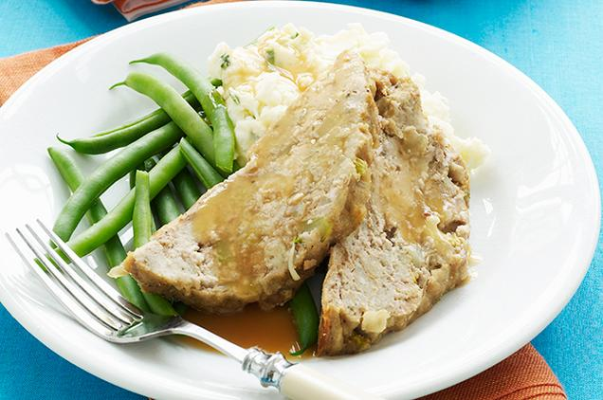Photo Credit iStock

**Pan Roasted Gravy**

Serves 6 with leftovers   
  
INGREDIENTS   
1/2 cup of dry white wine   
4 tablespoons of butter   
1/4-cup all-purpose flour   
1/2 cup of strained broth (pan drippings and cooked vegetables)   
Salt and pepper   
  
PREPARATION   
1. While turkey rests, place roasting pan over burners on medium high heat.   
2. Add wine; scrape bottom of pan to incorporate flavorful drippings from turkey and vegetables; let wine cook down a bit.   
3. Strain roasting pan into a saucepan; press down on vegetables to release flavorful juices.   
4. Let the gravy cool until fat rises to surface.   
5. Skim fat off surface; melt in fat.   
6. Add flour, whisking gravy constantly until lightly golden.   
7. Pour half of strained broth in and whisk until all lumps are velvety smooth.   
8. Add remainder of broth, whisking constantly.   
9. Bring to simmer and whisk frequently until thickened to your liking; season with salt and pepper.   
10. Serve with turkey and mashed potatoes.

**Mashed Potatoes**

Serves 6 with leftovers   
  
INGREDIENTS   
4 pounds golden potatoes, peeled and cut into quarters   
1/2 cup warmed half and half cream (half milk, half cream — you may use rice milk)   
3 tablespoons cream cheese   
3 tablespoons butter   
Salt and pepper to taste   
  
PREPARATION   
1. Put potatoes in 4 quarts pot and add water to cover.   
2. Bring to a boil; reduce heat and simmer until potatoes are tender (25 to 30) minutes.   
3. Pass cooked potatoes through a ricer or mash in bowl with hand masher.   
4. Add all remaining ingredients and mash until desired creaminess is achieved (add more cream if necessary)   
5. For more rustic texture, leave lumps.

**Strawberry Jelly**

Any organic grocery-store brand strawberry jam.

**Corn Niblets and Butter**

Serves 6 with leftovers   
  
INGREDIENTS   
You may substitute fresh corn cut off of 6 ears for frozen.   
  
1 bag of 16 ounces frozen corn (yellow or white)   
2 teaspoons salt   
1 stick of butter (8 tablespoons cut up)   
1/2 teaspoon of sugar   
1/2-cup water   
1/2 teaspoon of cornstarch   
  
PREPARATION   
1. Add corn to large saucepan along with all ingredients except water and cornstarch.   
2. Stir mixture over medium heat until butter melts.   
3. Combine water and cornstarch, stirring until cornstarch dissolves.   
4. Stir cornstarch mixture into corn; reduce heat to simmer; keep stirring until sauce thickens.   
5. Simmer, stirring occasionally until corn is tender, about 8 to 10 minutes.

**Steamed Green Beans**

Serves 6 with leftovers   
  
INGREDIENTS   
1 pound French green beans, stemmed   
2 tablespoons butter   
1/2 teaspoon salt   
1/2 teaspoon pepper   
  
PREPARATION   
1. In large pot boil 4 quarts of water; when water boils add butter, salt and pepper.   
2. Place beans in water and cook until desired tenderness is reached (5 to 8 minutes)   
3. Drain water; toss beans with more salt and pepper to taste.

**What makes turkey dinner a healthy meal**

Brad Pilon, author of “Eat Stop Eat,” says McCarthy’s meal is an example of a balanced diet. “The meal is a great balance of protein, carbs and fats as long as portions are kept to an acceptable size,” Pilon says.

**How to make turkey dinner even healthier**

According to Pilon, who holds a degree in Applied Human Nutrition from the University of Guelph, McCarthy’s meal could get a burst of anti-inflammatory and antioxidant benefits to combat free radicals (molecules that react with other substances in the body to create cell damage) by incorporating more herbs and spices.   
  
“I'd try spicing it up by adding rosemary to the mashed-potatoes and red chili flakes to the green beans” he says.

Read more: <http://www.livestrong.com/article/1004191-jenny-mccarthy-best-meal-ever/#ixzz2WQ6rwVZG>